**Insect Name: June Bug**

**My Digital Research Project**

**My Name: Sample Student**

**My Teacher: Mrs. Green**

**My picture   
 of the insect:**

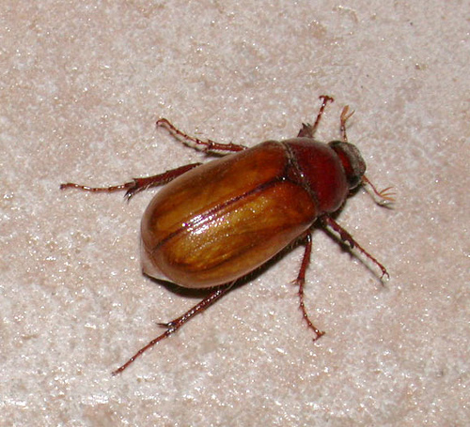

http://www.eattheweeds.com/wp-content/uploads/2011/11/june-bug-770c1.jpg

**Where does this insect live?**

**The June Bug is found in North America. It hides in trees.**

**What does this insect look like?**

**They are less than one inch long. They are dark brown or black. June Bugs have a hard shell with wings. I think they are ugly.**

**Fun Facts:**

**June Bugs got their name from showing up around the house in the month of June.**

**Lizards also like to eat June Bugs. Yuck!**

**How is the insect born?**

**First the June Bug is in an egg. Then it turns into a larva. Next, it turns into a pupa and finally becomes an adult. A June Bug can live up to four years.**