Self-Assessment Checklist:
Grade 1 - Word Processing Skills: Father’s Day Friendly Letter

Computer Skills:
I can . . .
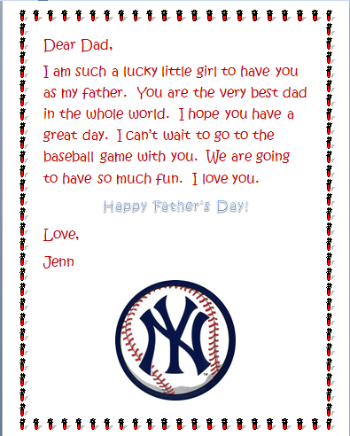
Double click open the Word program
Save As my document on my hard drive
Locate and Open my document
Add a page border
Change the font color
size
Change the font
Change the font name
Type capital letters using the SHIFT key
Use the ENTER key to drop down a line of text
Use the SPACE BAR key to make one space between each word.
Use the comma (,), apostrophe (’), period (.), and exclamation mark (!) keys.
Insert an image from the internet

English Language Arts- Writing Skills:
I can . . .
Type complete sentences
Include a greeting and closing for my letter
Include capital letters for proper nouns and to start sentences.
Use punctuation marks properly:
End marks (period, question mark, or exclamation mark)
Commas in greeting, closing, and date
Apostrophe for Father’s Day

