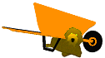
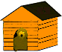
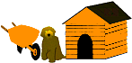
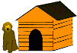
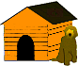
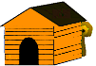
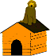
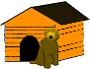
Directions: Copy each word/set of words and place it/them into the correct box next to the matching image using your left mouse button to select the word(s), your right mouse button to open a pop-up menu, and your left mouse button to select COPY. To paste, left click in the correct box, right click to open a pop-up menu, and left click to select PASTE. Hint: Since you are cutting the word(s), the word boxes should be empty.
Grade/Teacher:
Name:
under | on the right | on top | behind
In front | on the left | between | inside
CUT and Paste- Positional Words

