 |  | 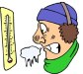
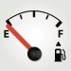 |  | 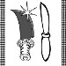
 |  | 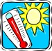
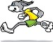
Directions: Copy each word and place it in the correct box next to the image with the opposite meaning using your left mouse button to select the word, your right mouse button to open a pop-up menu, and your left mouse button to select COPY. To paste, left click in the correct box, right click to open a pop-up menu, and left click to select PASTE.
Grade/Teacher:
Name:
Dirty | Exit | Young | Late
Clean | Slow | Poor | OFF
Wet | Sad | Dull | Rich
Full | Fast | Cold | Hot

