Directions: Copy each word and place it into the correct box next to the matching image using your left mouse button to select the item, your right mouse button to open a pop-up menu, and your left mouse button to select COPY. To paste, left click in the correct box, right click to open a pop-up menu, and left click to select PASTE.
Grade/Teacher:
Name:
Monitor | Keyboard | CPU tower | Webcam
Mouse | Printer | DVD drive | Flash drive
Speakers | Tablet/ iPad | Headphones | Video Camera
Digital Camera | Blank CDs | Microphone | E-Reader
 |  | 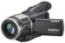
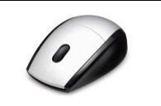 |  | 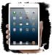
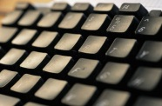 |  | 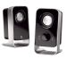
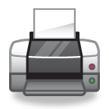 |  | 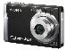
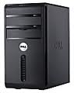 |  | 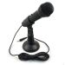
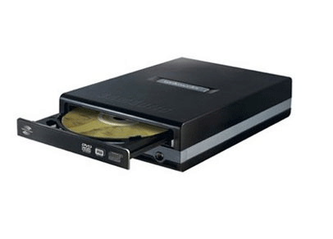 |  | 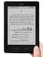
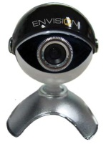
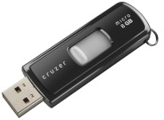 |  | 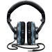
Copy and Paste- Computer Parts TEST

