Directions: Copy each image and place it in the correct box next to the image with the matching fraction using your left mouse button to select the word, your right mouse button to open a pop-up menu, and your left mouse button to select COPY. To paste, left click in the correct box, right click to open a pop-up menu, and left click to select PASTE.
Grade/Teacher:
Name:
 | 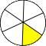 |  | 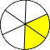
 | 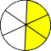 | 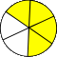 | 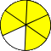
Copy and Paste Fractions
1/3
1/6
2/3
2/6
3/6
5/6
3/3
4/6

