PERSONAL BLOG- ALL ABOUT ME PROFILE PAGE
For this lesson, you will make an ALL ABOUT ME Profile Page for a Personal Blog (a blog all about you!). Take a few minutes to read my example of the finished post. Then read and follow the directions on the MY PROFILE worksheet. You should consider that your first draft and a place to edit your work. Proof read for grammar and spelling. Organize your thoughts in well written paragraphs.
My Example:
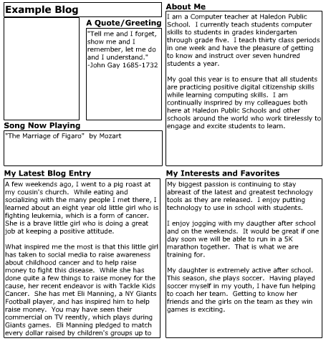
Notice how mine got cut off? This is why I suggest keeping your paragraphs limited. You still need to provide enough information, but you can’t be too wordy or the information will not show on your final project. Have Fun!

